**Car Repair Shop**

Câmpan Tudor-Cosmin

30423

Year II, CTI

This project will simulate the activity of a Car Repair Shop. Cars will have 3 states, “Nediagnosticat”, “Diagnosticat” și “Reparat”.

The user will have to introduce the cars in the application, along with their plate number, their owner’s telephone number and their owner’s budget. There is also a yard, so in the garage and yard can be no more than 20 cars and in the garage can be no more than 12.

The app shows information about every car in the garage and its’ state, owner telephone and license plate. The user can diagnose and repair cars. When the user tries to diagnose a car that is already diagnosed, a warning will pop up. Also warnings will pop up when you try to repair undiagnosed cars and when you try to repair cars that are already repaired.

There is also a feature that shows the number of cars in the yard, and there is information provided about the shops’ budget.

There is a feature which takes the cash from the owner and pops the car out of the shop. In case the owner doesn’t have the necessary budget to take the car out, a warning message will pop up. There is a phone-number field, where the owner calls that he has money, and his budget will be raised. Now he can take his car out of the shop.

When the user tries to repair or take out cars that don’t exist, a warning message will pop up.

There are also the garage cleaner, which takes repaired cars from the shop and put them in the yard, and the yard cleaner which pushes undiagnosed cars into the shop.

There is a label that shows the repaired cars in the yard, for the user to know which cars can take out.

When the user is trying to pull cars from the yard into the garage and in the garage are already 12 cars, a message saying that is popping in the error label window.

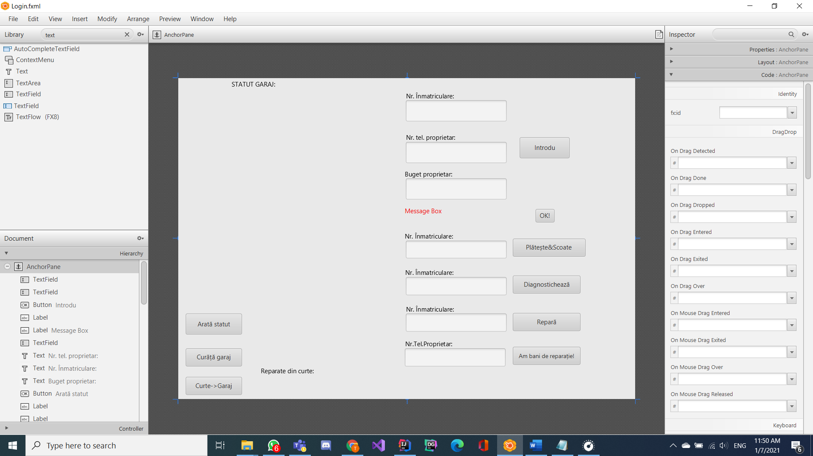

This is how the interface looks, with all the fields to be completed by the user, all the buttons for the action and the message label.

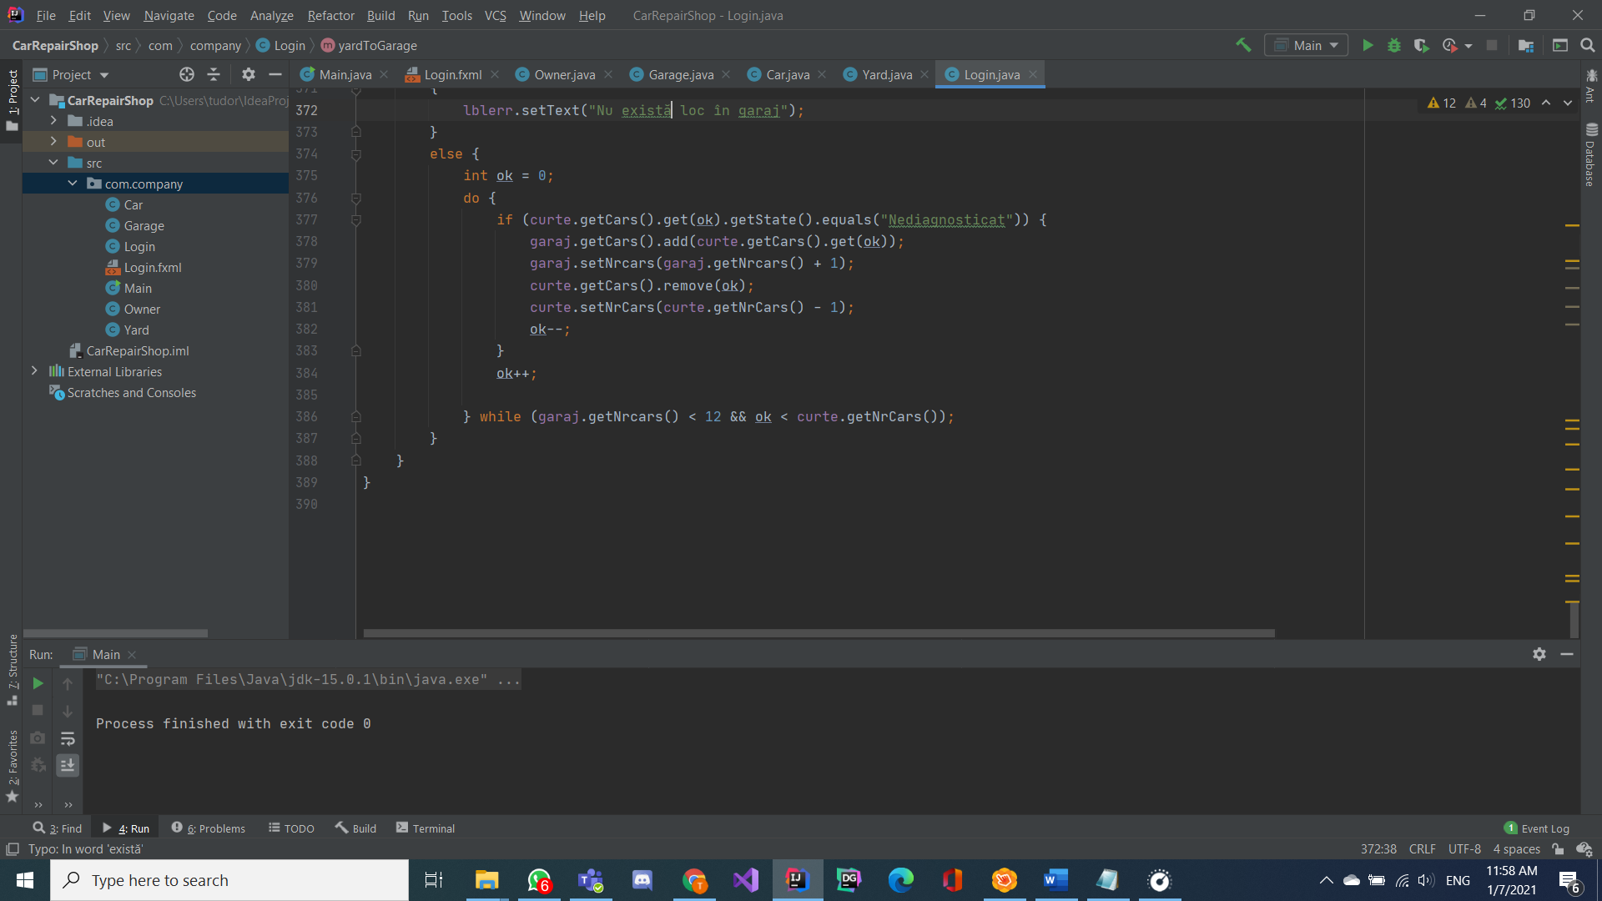

These are the classes in my project. Apart from Login class, they mostly have setters and getters because I have put all the important functions in the login class.

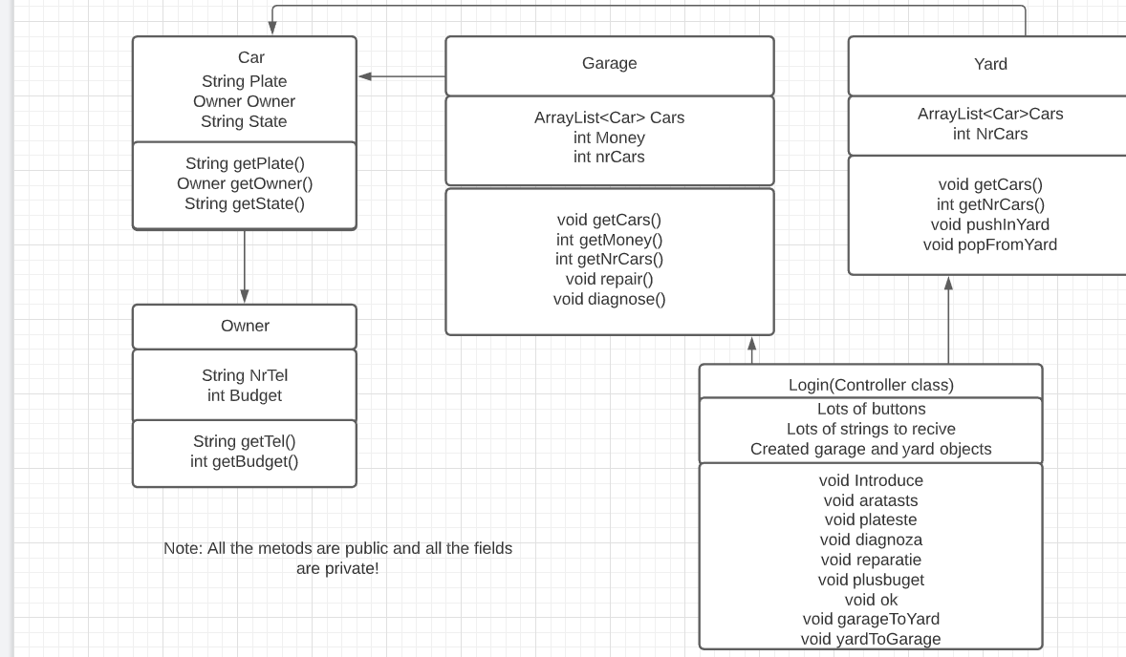

This would be the diagram. The controller class is the most complex, it has 9 handmade functions:

-Introduce: receives data from the user and introduces a new car.

-aratasts: show the status of the garage and yard.

-plateste:receives the plate from the user , receives the mony and gets the car out(only if the user has the necessary money, if not, a it pops an error message up).

-diagnoza: diagnoses a car that is not diagnosed.

-reparatie: repairs a car that is diagnosed but not repaired.

-plusbudget: adds a budget to an owner in order to pay for the repair of his car.

-ok: wipes the error message from the error label.

-garageToYard cleans the garage.

-yardToGarage pops the undiagnosed cars into the garage.